**Team 5**

We have a one master organization repository where we thought will be collecting all project assignments. However due to some problems with the user of that organization we had some problems to access the link and upload our completions there. But we solved this problem and submitting this assignment as follow:

1. We have two links because there are two branches that we are using in GitHub because we couldn’t come together with all members in one link. Therefore we decided to create branches and in each branch there are two members. In my link me and Aiipbek and in Bekbolsun’s link Bekbolsun by himself and Aiipbek.

Sorry for that inconvenience, we are going to try to solve that issue and show of all members in one link in the future

<https://github.com/kisaev/ShoppingWebsiteUML>

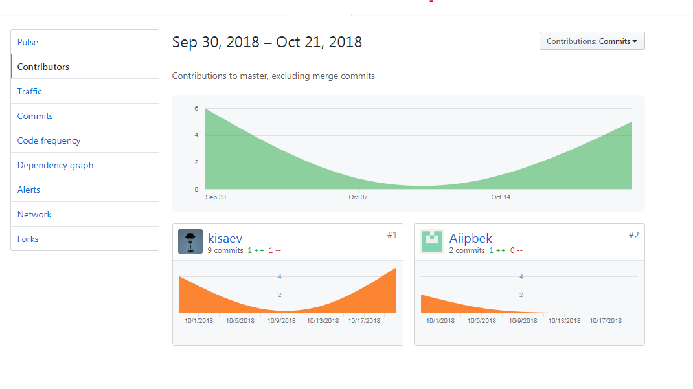

<https://github.com/bektenov/ShoppingWebsite/graphs/contributors>

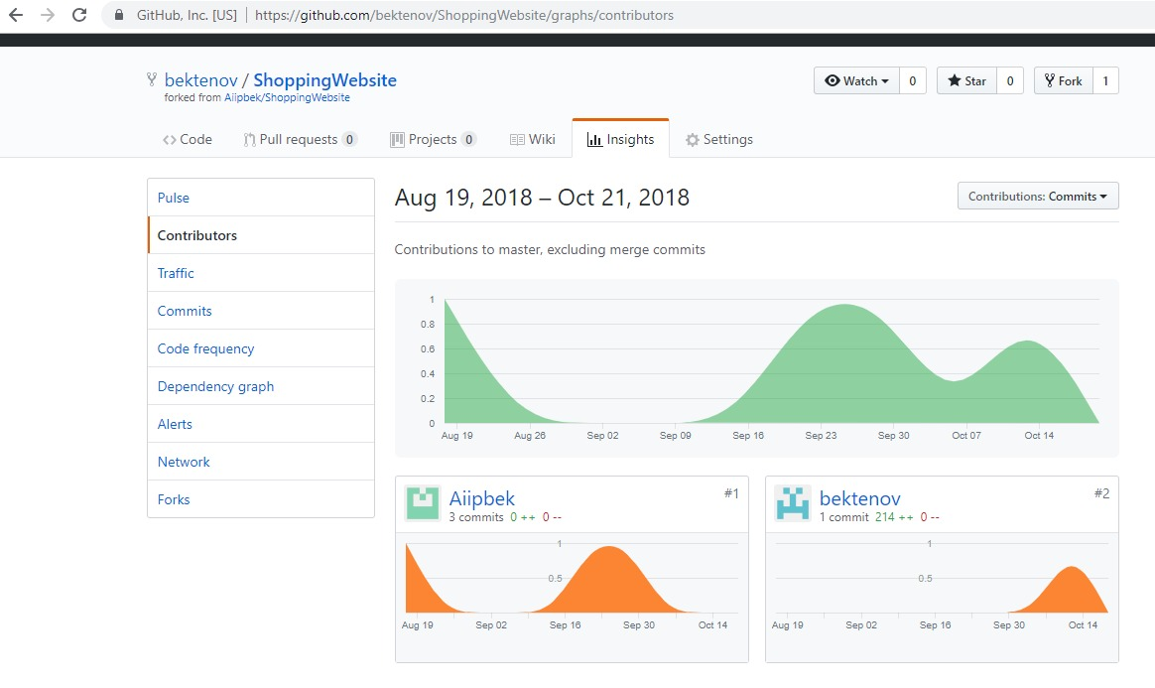

[bbektenov@na.edu](mailto:bbektenov@na.edu) – Bekbolsun Bektenov

[kisaev@na.edu](mailto:kisaev@na.edu) – Kalysbek Isaev

[azhunusov@na.edu](mailto:azhunusov@na.edu) – Aiipbek Zhunusov